YEAR 2 HOME LEARNING
Date Set | 10.03.23
Date Due | 15.03.23
Maths | Please log onto EdShed (https://www.edshed.com/en-gb/login) where you will find your maths home learning under assignments. Good luck!
Spelling  Writing | Please log onto EdShed (https://www.edshed.com/en-gb/login) where you will find your spelling home learning under assignments.  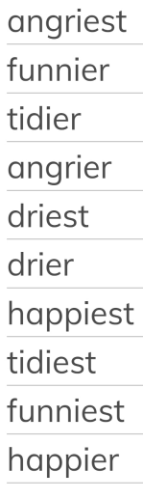  Writing Task  Please complete a fact file on the bird breed Puffins in Wales. Remember to include a picture of them!
Reading | Recommended daily reading time:  KS1 15-20 minutes.
Greek | Please go to Greek Class Blog for Greek Home Learning  Greek Class - St Cyprian's Greek Orthodox Primary Academy

