YEAR 4 HOME LEARNING
Date Set | 17.03.23
Date Due | 22.03.23
Maths | Please log onto EdShed (https://www.edshed.com/en-gb/login) where you will find your maths home learning under assignments. Good luck!  Please also complete TTRS every day to help with your times tables.
Spelling  Writing | Please log onto EdShed (https://www.edshed.com/en-gb/login) where you will find your spelling home learning under assignments.  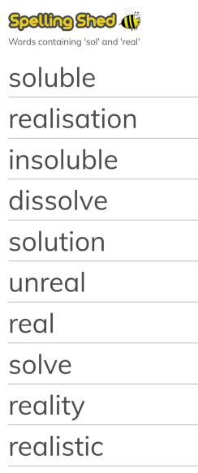  Writing Task  Imagine you are a drop of water. You start your journey on a mountain top where you travel down in the rain or snow to a river below. Where do you go next? How is it possible that you end up back on the mountain top?  You should use the attachment provided.
Reading | Recommended daily reading time:  KS2 40 minutes.
Greek | Please go to Greek Class Blog for Greek Home Learning  Greek Class - St Cyprian's Greek Orthodox Primary Academy

