YEAR 4 HOME LEARNING
Date Set | 24.03.23
Date Due | 29.03.23
Maths | Please log onto EdShed (https://www.edshed.com/en-gb/login) where you will find your maths home learning under assignments. Good luck!  Please also complete TTRS every day to help with your times tables.
Spelling  Writing | Please log onto EdShed (https://www.edshed.com/en-gb/login) where you will find your spelling home learning under assignments.  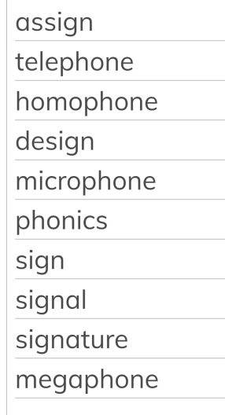  Writing Task  - Make a poster that explains the water cycle.  - Write a letter from Jesus to Judas about how he felt when he washed Judas’ feet. Use our poem to help you with what Jesus might have been thinking.
Reading | Recommended daily reading time:  KS2 40 minutes.
Greek | Please go to Greek Class Blog for Greek Home Learning  Greek Class - St Cyprian's Greek Orthodox Primary Academy

