YEAR 4 HOME LEARNING
Date Set | 31.03.23
Date Due | 19.04.23
Maths | Please log onto EdShed (https://www.edshed.com/en-gb/login) where you will find your maths home learning under assignments. Good luck!  Please also complete TTRS every day to help with your times tables.
Spelling  Handwriting  Comprehension | Please log onto EdShed (https://www.edshed.com/en-gb/login) where you will find your spelling home learning under assignments.  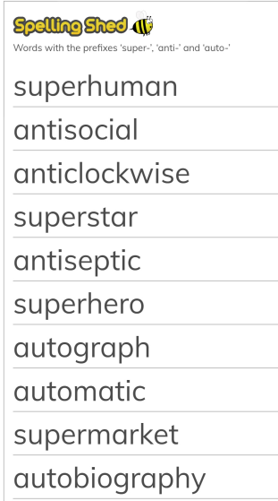  Writing Task  - Write a newspaper report about the first Olympic Games! Watch this to help you:  KS2 Ancient Greece: 4. The Olympic Games (but not as we know them) - BBC Teach  You will have been given a handwriting sheet and a comprehension activity by your teacher.
Reading | Recommended daily reading time:  KS2 40 minutes.
Greek | Please go to Greek Class Blog for Greek Home Learning  Greek Class - St Cyprian's Greek Orthodox Primary Academy

