RECEPTION HOME LEARNING
Date Set | 10.03.2023
Date Due | 16.03.2023
Maths | Practice the number formation with the rhymes and shapes.  Can you identify any shapes around the house? Can you name the objects and use your phonetic knowledge to write a word?  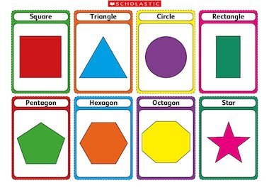
Phonics  English | Click on the link below to practice some sounds  DAILY PHONICS PRACTICE Read Write Inc Phonics Set 1 The Shed School - YouTube
Reading | Recommended daily reading time:  Nursery 5-10 minutes.  Reception 15-20 minutes.

