YEAR 2 HOME LEARNING
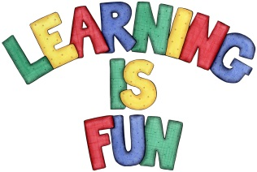
Date Set | 28.04.23
Date Due | 03.05.23
Maths | Please log onto EdShed (https://www.edshed.com/en-gb/login) where you will find your maths home learning under assignments. Good luck!
Spelling  Writing | Please log onto EdShed (https://www.edshed.com/en-gb/login) where you will find your spelling home learning under assignments.  - patted  - hummed  - dropped  - clapped  - clipped  - wrapped  - napped  - ripped  - drummed  - dragged  Writing Task  This week, for their writing task, we would like the children to write a letter to King Charles ahead of his coronation. Include how you will be celebrating his coronation and what you wish him luck in!
Reading | Recommended daily reading time:  KS1 15-20 minutes.  KS2 40 minutes.
Greek | Please go to Greek Class Blog for Greek Home Learning  Greek Class - St Cyprian's Greek Orthodox Primary Academy

