YEAR 2 HOME LEARNING
Date Set | 05.05.23
Date Due | 10.05.23
Maths | Please log onto EdShed (https://www.edshed.com/en-gb/login) where you will find your maths home learning under assignments. Good luck!
Spelling  Writing | Please log onto EdShed (https://www.edshed.com/en-gb/login) where you will find your spelling home learning under assignments.  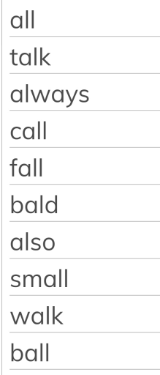  Writing Task  This week, for your writing task, we would like you to create an informative poster on Sir Francis Drake. Include some interesting facts and a picture!
Reading | Recommended daily reading time:  KS1 15-20 minutes.  KS2 40 minutes.
Greek | Please go to Greek Class Blog for Greek Home Learning  Greek Class - St Cyprian's Greek Orthodox Primary Academy

