YEAR 2 HOME LEARNING
Date Set | 19.05.23
Date Due | 24.05.23
Maths | Please log onto EdShed (https://www.edshed.com/en-gb/login) where you will find your maths home learning under assignments. Good luck!
Spelling  Writing | Please log onto EdShed (https://www.edshed.com/en-gb/login) where you will find your spelling home learning under assignments.  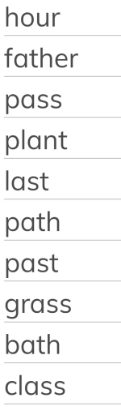  Writing Task  Research any pirate and create a fact file on them! Make sure you include the following details:  - Name  - Date of birth  - Date of death  - Information about their life and achievements  - Interesting fact
Reading | Recommended daily reading time:  KS1 15-20 minutes.  KS2 40 minutes.
Greek | Please go to Greek Class Blog for Greek Home Learning  Greek Class - St Cyprian's Greek Orthodox Primary Academy

