YEAR 4 HOME LEARNING
Date Set | 12.05.23
Date Due | 18.05.23
Maths | Please log onto EdShed (https://www.edshed.com/en-gb/login) or Purple Mash Practise your times tables please.  Please also complete TTRS every day to help with your times tables. It is really important that you know your tables!
Spelling  Writing | Please log onto EdShed (https://www.edshed.com/en-gb/login) where you will find your spelling home learning under assignments.  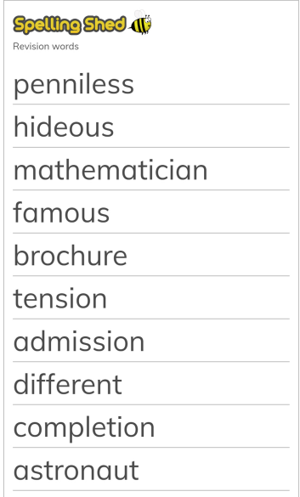  Writing Task  Look through the attached sheet that asks you to correct the punctuation and spelling and then WRITE OUT the corrected and completed version in your NEATEST handwriting.
Reading | Recommended daily reading time:  KS2 40 minutes.  There is also a comprehension task for you – you can write your answers in your pink book.
Greek | Please go to Greek Class Blog for Greek Home Learning  Greek Class - St Cyprian's Greek Orthodox Primary Academy

