YEAR 4 HOME LEARNING
Date Set | 19.05.23
Date Due | 24.05.23
Maths | Please log onto EdShed (https://www.edshed.com/en-gb/login) or Purple Mash Practise your times tables please.  Please also complete TTRS every day to help with your times tables. It is really important that you know your tables!
Spelling  Writing | Please log onto EdShed (https://www.edshed.com/en-gb/login) where you will find your spelling home learning under assignments.  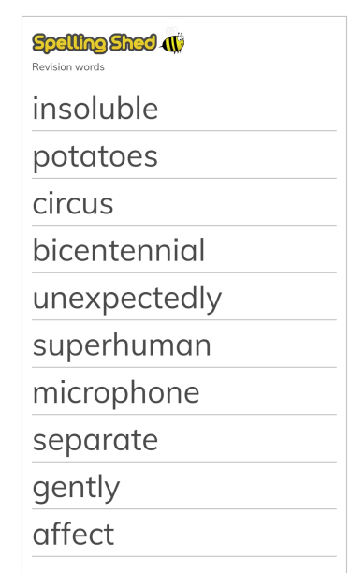  Writing Task  Describe this picture and then write a story about who lives here.
Reading | Recommended daily reading time:  KS2 40 minutes.
Greek | Please go to Greek Class Blog for Greek Home Learning  Greek Class - St Cyprian's Greek Orthodox Primary Academy

