YEAR 4 HOME LEARNING
Date Set | 26.05.23
Date Due | 07.06.23
Maths | Please log onto EdShed (https://www.edshed.com/en-gb/login) or Purple Mash Practise your times tables please.  Please also complete TTRS every day to help with your times tables. It is really important that you know your tables!
Spelling  Writing | Please log onto EdShed (https://www.edshed.com/en-gb/login) where you will find your spelling home learning under assignments.  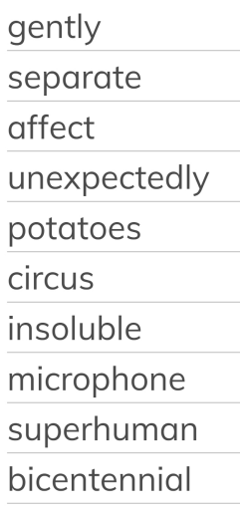  Writing Task  Choose a character, scene and situation (one from each list) and write a story! Include adverbial phrases,  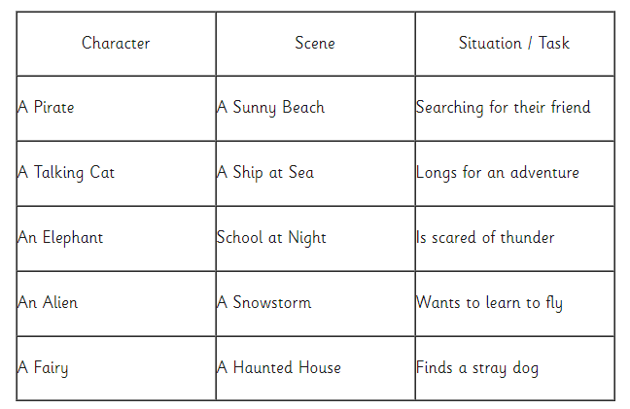  expanded noun phrases and apostrophes in your writing.
Reading | Recommended daily reading time:  KS2 40 minutes.
Greek | Please go to Greek Class Blog for Greek Home Learning  Greek Class - St Cyprian's Greek Orthodox Primary Academy

