YEAR 2 HOME LEARNING
Date Set | 23.06.23
Date Due | 28.06.23
Maths | Please log onto EdShed (https://www.edshed.com/en-gb/login) where you will find your maths home learning under assignments. Good luck!
Spelling  Writing | Please log onto EdShed (https://www.edshed.com/en-gb/login) where you will find your spelling home learning under assignments.  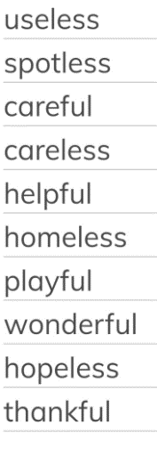  Writing Task  For this week we would like you to write an alternative ending to Jack and the Beanstalk. Think about what would happen if the giant didn’t come down the beanstalk after Jack. How would the magic beans change Jack’s life?
Reading | Recommended daily reading time:  KS1 15-20 minutes.  KS2 40 minutes.
Greek | Please go to Greek Class Blog for Greek Home Learning  Greek Class - St Cyprian's Greek Orthodox Primary Academy

