YEAR 2 HOME LEARNING
Date Set | 16.06.23
Date Due | 21.06.23
Maths | Please log onto EdShed (https://www.edshed.com/en-gb/login) where you will find your maths home learning under assignments. Good luck!
Spelling  Writing | Please log onto EdShed (https://www.edshed.com/en-gb/login) where you will find your spelling home learning under assignments.  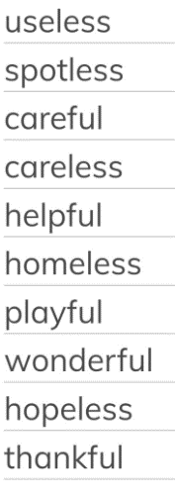  Writing Task  For this week we would like you to write a spooky story based on this picture. Make sure you describe the setting and how you’re feeling. Include adjectives and noun phrases.
Reading | Recommended daily reading time:  KS1 15-20 minutes.  KS2 40 minutes.
Greek | Please go to Greek Class Blog for Greek Home Learning  Greek Class - St Cyprian's Greek Orthodox Primary Academy

