YEAR 4 HOME LEARNING
Date Set | 16.06.23
Date Due | 24.0623
Maths | Please log onto EdShed (https://www.edshed.com/en-gb/login) We are looking at decimals.Please also complete TTRS every day to help with your times tables. It is really important that you know your tables! Please practice the inverse too.
Spelling  Writing | There is an additional sheet in the pack this week to help with SPAG. Please do one or more every day and see how you get on.  Writing Task  Look at the information below.  Now, re-write this information as a paragraph instead of using subtitles. (Think about what we have done in class to help you.)  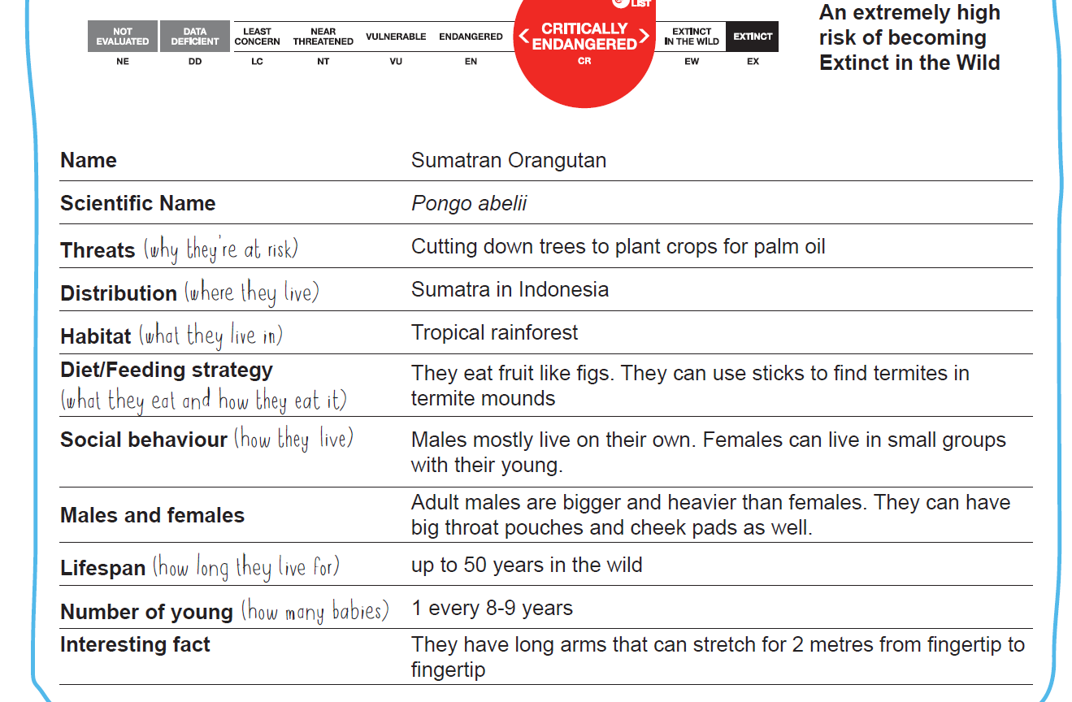  You can use these sentences to start you off: The Sumatran Orangutan live in the Indonesian Rainforest. They are a critically endangered species. Their favourite food is…
Reading | Recommended daily reading time:  KS2 40 minutes.
Greek | Please go to Greek Class Blog for Greek Home Learning  Greek Class - St Cyprian's Greek Orthodox Primary Academy

