YEAR 4 HOME LEARNING
Date Set | 30.06.23
Date Due | 05.07.23
Maths | Please log onto EdShed (https://www.edshed.com/en-gb/login) We are looking at decimals.Please also complete TTRS every day to help with your times tables. It is really important that you know your tables! Please practice the inverse too.
Spelling  Writing | 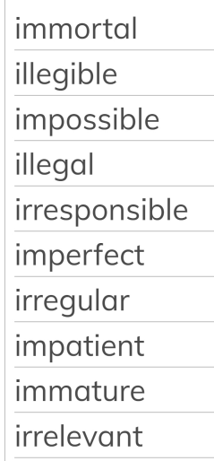  Writing Task  Re-write this story setting and make it excellent! How could you develop this writing?
Reading | Recommended daily reading time:  KS2 40 minutes.
Greek | Please go to Greek Class Blog for Greek Home Learning  Greek Class - St Cyprian's Greek Orthodox Primary Academy

