YEAR 2 HOME LEARNING
Date Set | 15.09.23
Date Due | 20.09.23
Maths | Please log onto EdShed (https://www.edshed.com/en-gb/login) where you will find your maths home learning under assignments. Good luck!
Spelling  Writing | Please log onto EdShed (https://www.edshed.com/en-gb/login) where you will find your spelling home learning under assignments. You will be challenged on these so make sure you practise.  - range  - hinge  - sponge  - change  - fringe  - orange  - dungeon  - pigeon  - strange  - charge  Writing Task  This week, we would like you to copy out the following sentences but add the missing capital letters and full stops.  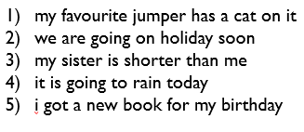  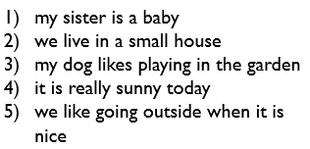
Reading | Recommended daily reading time:  KS1 15-20 minutes.  KS2 40 minutes.
Greek | Please go to Greek Class Blog for Greek Home Learning  Greek Class - St Cyprian's Greek Orthodox Primary Academy

