YEAR 1 HOME LEARNING
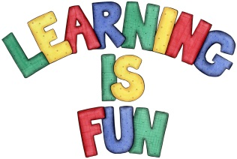
Date Set | 6.10.23
Date Due | 11.10.23
Maths | Please log onto EdShed (https://www.edshed.com/en-gb/login) where you will find your maths home learning under assignments. Good luck!  The children will be ordering objects using their knowledge of greater than, less than and equal to.
Spelling  Writing | For spellings, we will be focusing on common exception words. We do a spelling test on the Wednesday so please make sure that these are done!  Writing Task – Using capital letters and full stops.  Correct the sentences.  the cat sat on the mat  sam has a bad leg  jen has a big hat  the pig is in the bin  i had a red dog
Reading | Recommended daily reading time:  KS1 10 minutes
Greek | Please go to Greek Class Blog for Greek Home Learning  Greek Class - St Cyprian's Greek Orthodox Primary Academy

