YEAR 1 HOME LEARNING
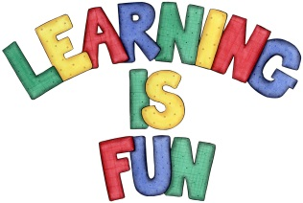
Date Set | 20.10.23
Date Due | 30.10.23
Maths | Please log onto EdShed (https://www.edshed.com/en-gb/login) where you will find your maths home learning under assignments. Good luck!  There will be no assignment this week as we feel that the children have earned a rest, but there are still games you can access on EdShed if you would like to this half term.
Project | Local celebrity fact file.  Research a celebrity from your local area and collect some facts about them. Then draw a picture of them and write some facts that you have found out about your chosen local celebrity. Below are some examples, as well as a format on the adjoining page to help you with the layout.  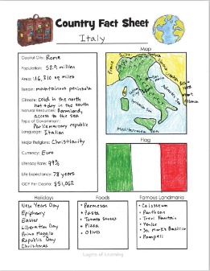  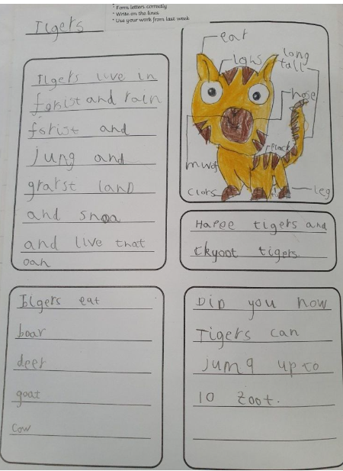
Reading | Recommended daily reading time:  KS1 10 minutes
Greek | Please go to Greek Class Blog for Greek Home Learning  Greek Class - St Cyprian's Greek Orthodox Primary Academy

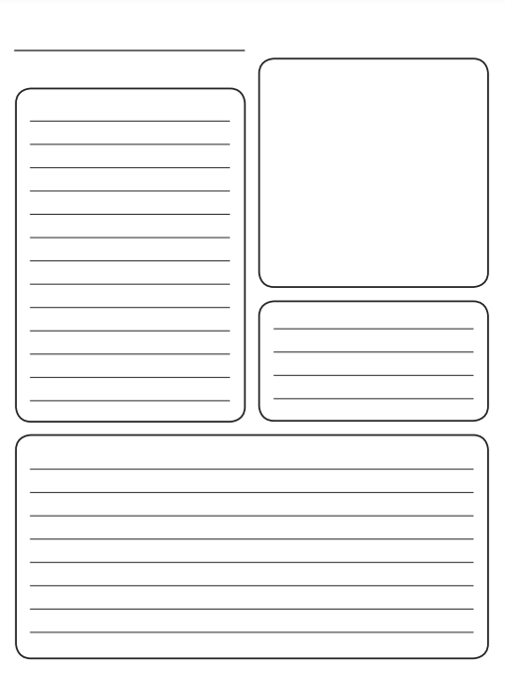
Fact file template

