YEAR 1 HOME LEARNING
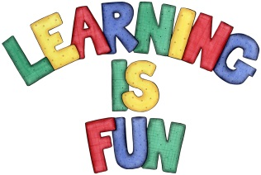
Date Set | 3.11.23
Date Due | 8.11.23
Maths | Please log onto EdShed (https://www.edshed.com/en-gb/login) where you will find your maths home learning under assignments. Good luck!  This week the children started learning about subtraction, and to solidify that knowledge this week’s focus will be understanding partitioning for subtraction.
Spelling  Writing | For spellings, the children will be focusing in words ending in ‘ff’, ‘ss’, ‘ll’, ‘zz’ and ‘ck’.  Writing Task  For the writing task this week, we would like the children to write a descriptive sentence about their favourite toy. For example, The round ball or the fluffy teddy.
Reading | Recommended daily reading time:  KS1 10 minutes
Greek | Please go to Greek Class Blog for Greek Home Learning  Greek Class - St Cyprian's Greek Orthodox Primary Academy

