YEAR 1 HOME LEARNING
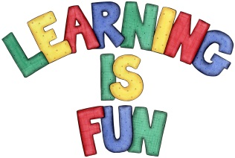
Date Set | 10.11.23
Date Due | 15.11.23
Maths | Please log onto EdShed (https://www.edshed.com/en-gb/login) where you will find your maths home learning under assignments. Good luck!  This week the children’s maths will be focused on subtraction on a number line.
Spelling  Writing | For spellings, the children will continue to focus on words ending in ‘ff’, ‘ss’, ‘ll’, ‘zz’ and ‘ck’.  Writing Task  For the writing task this week, we would like the children to write some sentences on what they like about the story of Katie in London so far!  Don’t forget, names have capital letters!  The characters are called Grandma, Katie, Jack and the lion.  Are you up for a challenge?  Can you include an exclamation mark in your writing?
Reading | Recommended daily reading time:  KS1 10 minutes
Greek | Please go to Greek Class Blog for Greek Home Learning  Greek Class - St Cyprian's Greek Orthodox Primary Academy

