YEAR 1 HOME LEARNING
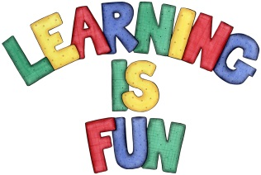
Date Set | 17.11.23
Date Due | 22.11.23
Maths | Please log onto EdShed (https://www.edshed.com/en-gb/login) where you will find your maths home learning under assignments. Good luck!  This week the children’s maths will be focused on 2D Shapes.
Spelling  Writing | For spellings, the children will continue to focus on words ending in ‘ff’, ‘ss’, ‘ll’, ‘zz’ and ‘ck’.  Writing Task  Imagine you are Katie or Jack resting with the lion in the park. Where would you like the lion to take you on your next adventure? It doesn’t have to be in London.  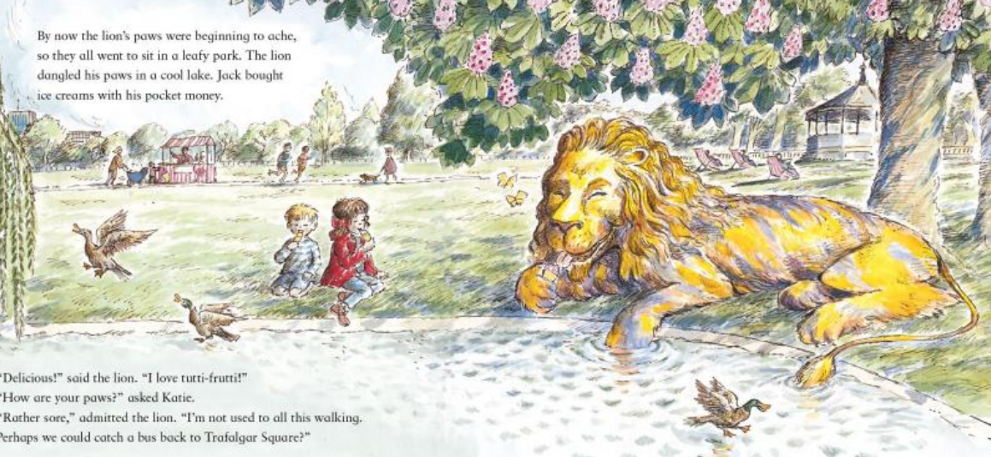  You can draw or write sentences about your exciting adventure.  Would it be:  Outer space? To a seaside? To a jungle?  What do you do? What do you see? How do you feel?
Reading | Recommended daily reading time:  KS1 10 minutes
Greek | Please go to Greek Class Blog for Greek Home Learning  Greek Class - St Cyprian's Greek Orthodox Primary Academy

