YEAR 1 HOME LEARNING
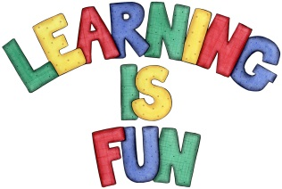
Date Set | 24.11.23
Date Due | 29.11.23
Maths | Please log onto EdShed (https://www.edshed.com/en-gb/login) where you will find your maths home learning under assignments. Good luck!  This week the children’s maths have been focusing on 2D Shapes and 3D Shapes.
Spelling  Writing | For spellings, the children will continue to focus on words ending in ‘ff’, ‘ss’, ‘ll’, ‘zz’ and ‘ck’.  Writing Task – Draw or write sentences  Imagine that you were at an Art gallery like Katie.  - What picture would you go and look at?  - What would you do if you climbed in that picture?  For example:  The Beach The Funfair On the Race Track
Reading | Recommended daily reading time:  KS1 10 minutes
Greek | Please go to Greek Class Blog for Greek Home Learning  Greek Class - St Cyprian's Greek Orthodox Primary Academy

