YEAR 1 HOME LEARNING
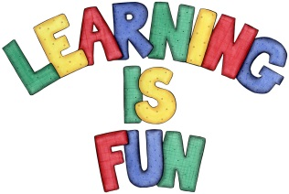
Date Set | 01.12.23
Date Due | 06.12.23
Maths | Please log onto EdShed (https://www.edshed.com/en-gb/login) where you will find your maths home learning under assignments. Good luck!  This week the children will be consolidating their knowledge of addition facts.
Spelling  Writing | For spellings, the children will be focusing on words ending in ‘k’ and ‘nk’.  Writing Task  This week, we would like the children to draw their favourite toy. Then identify the materials that it is made from, as well as name some of the properties that it has, and write them around the picture.
Reading | Recommended daily reading time:  KS1 10 minutes
Greek | Please go to Greek Class Blog for Greek Home Learning  Greek Class - St Cyprian's Greek Orthodox Primary Academy

