YEAR 1 HOME LEARNING
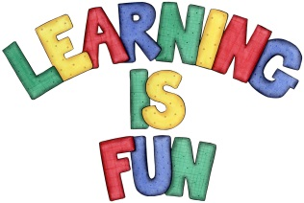
Date Set | 08.12.23
Date Due | 15.12.23
Maths | Please log onto EdShed (https://www.edshed.com/en-gb/login) where you will find your maths home learning under assignments. Good luck!  This week the children will be consolidating their knowledge of greater than, less than and equal to.
Spelling  Writing | For spellings, the children will be focusing on words ending in ‘k’ and ‘nk’.  Writing Task  Imagine that Saint Nicholas came to your house. What questions would you like to ask him? Remember to use one of the question words How? What? When? Where? Who? Why? and put a question mark ? at the end of your sentence:  For example: How did you feel going to church as a young boy?  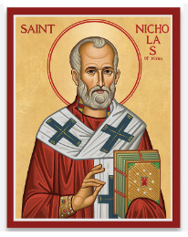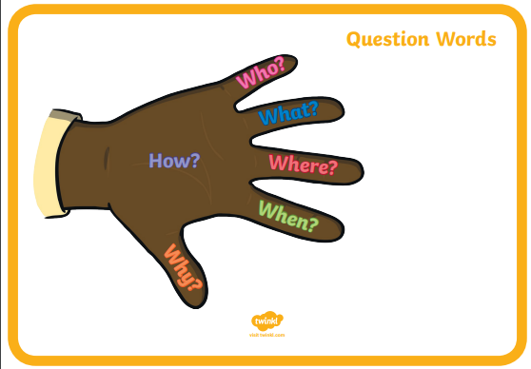
Reading | Recommended daily reading time:  KS1 10 minutes
Greek | Please go to Greek Class Blog for Greek Home Learning  Greek Class - St Cyprian's Greek Orthodox Primary Academy

