YEAR 1 HOME LEARNING
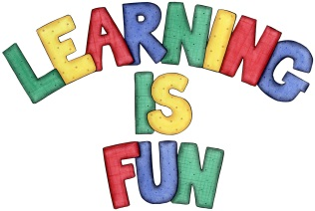
Date Set | 15.12.23
Date Due | 20.12.23
Maths | Please log onto EdShed (https://www.edshed.com/en-gb/login) where you will find your maths home learning under assignments. Good luck!  This week the children will be revisiting subtraction.
Spelling  Writing | For spellings, the children will be focusing on words ending in common exception words and words ending in ‘nk’ and ‘k’.  Writing Task  Write a letter to Santa telling him what you want for Christmas this year.  Maybe if you are feeling like an extra challenge you can send him some questions! E.g. How old is Santa? Why did you change your name from St.Nicholas?
Reading | Recommended daily reading time:  KS1 10 minutes
Greek | Please go to Greek Class Blog for Greek Home Learning  Greek Class - St Cyprian's Greek Orthodox Primary Academy

