YEAR 1 HOME LEARNING
Date Set | 26.01.24
Date Due | 31.01.24
Maths | Please log onto EdShed (https://www.edshed.com/en-gb/login) where you will find your maths home learning under assignments. Good luck!  This week the children will be looking at how we understand 20.
Spelling  Writing | For spellings, the children will be focusing on words ending in the suffix -s, and -es.  Writing Task  Choose ‘5’ sentences, write them in your book and underline the adjectives.  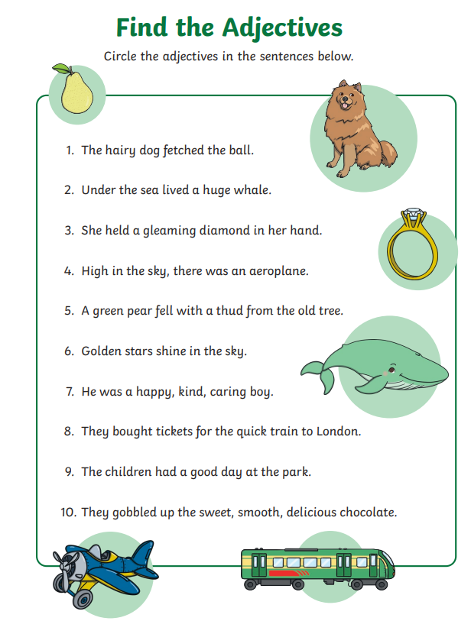
Reading | Recommended daily reading time:  KS1 10 minutes
Greek | Please go to Greek Class Blog for Greek Home Learning  Greek Class - St Cyprian's Greek Orthodox Primary Academy

