YEAR 1 HOME LEARNING
Date Set | 09.02.24
Date Due | 14.02.24
Maths | Please log onto EdShed (https://www.edshed.com/en-gb/login) where you will find your maths home learning under assignments. Good luck!
Spelling  Writing | For spellings, the children will be focusing on the next 6 Common Exception Words: said, says, are, were, was, is.  Writing Task  Us the common exception words that you learnt last week a, the, do, to, today, to fill in the missing word. Then write your own sentences using the words.  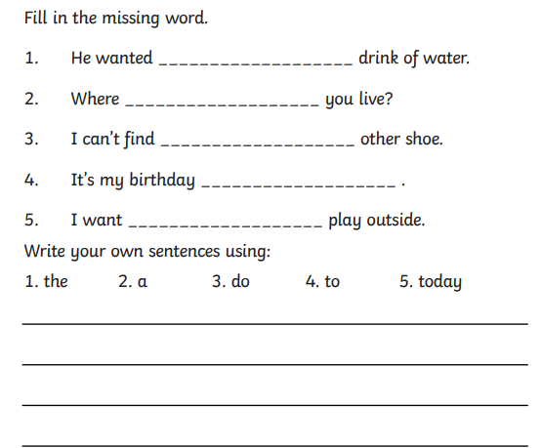
Reading | Recommended daily reading time:  KS1 10 minutes
Greek | Please go to Greek Class Blog for Greek Home Learning  Greek Class - St Cyprian's Greek Orthodox Primary Academy

