YEAR 1 HOME LEARNING
Date Set | 16.02.24
Date Due | 28.02.24
Maths | Please log onto EdShed (https://www.edshed.com/en-gb/login) where you will find your maths home learning under assignments. Good luck!
Spelling  Project | For spellings, the children will be focusing on the next 6 Common Exception Words: school, people, here, where, full, put  Project  Over the half term, we would like you to try and make a shoe box diorama of your favourite animal’s habitat. For an extra challenge, you could add some fun facts about your favourite animal.  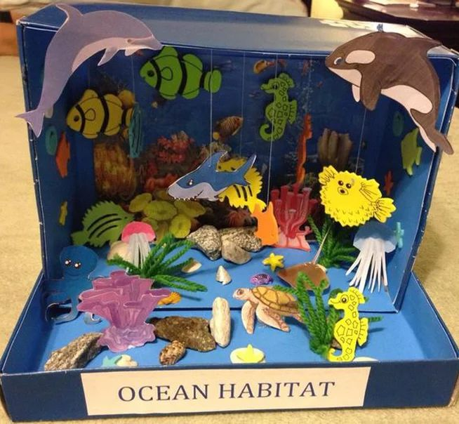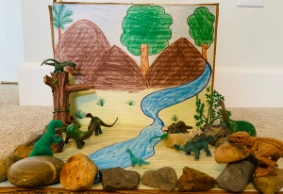
Reading | Recommended daily reading time:  KS1 10 minutes
Greek | Please go to Greek Class Blog for Greek Home Learning  Greek Class - St Cyprian's Greek Orthodox Primary Academy

