YEAR 2 HOME LEARNING
Date Set | 02.02.24
Date Due | 07.02.24
Maths | Please log onto EdShed (https://www.edshed.com/en-gb/login) where you will find your maths home learning under assignments. Good luck!
Spelling  Writing | Please log onto EdShed (https://www.edshed.com/en-gb/login) where you will find your spelling home learning under assignments.  Writing Task  This week, we would like you to copy out the following sentences and underline the verbs.  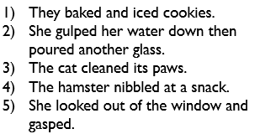  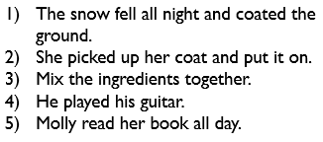
Reading | Recommended daily reading time:  KS1 15-20 minutes.  KS2 40 minutes.
Greek | Please go to Greek Class Blog for Greek Home Learning  Greek Class - St Cyprian's Greek Orthodox Primary Academy

