YEAR 1 HOME LEARNING
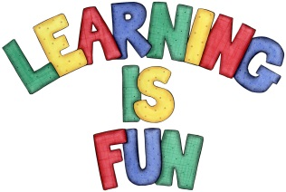
Date Set | 08.03.24
Date Due | 13.03.24
Maths | Please log onto EdShed (https://www.edshed.com/en-gb/login) where you will find your maths home learning under assignments. Good luck!
Spelling | For spellings, the children will be focusing on the next 6 common exception words: put, she, school, you, of, come  Writing Task  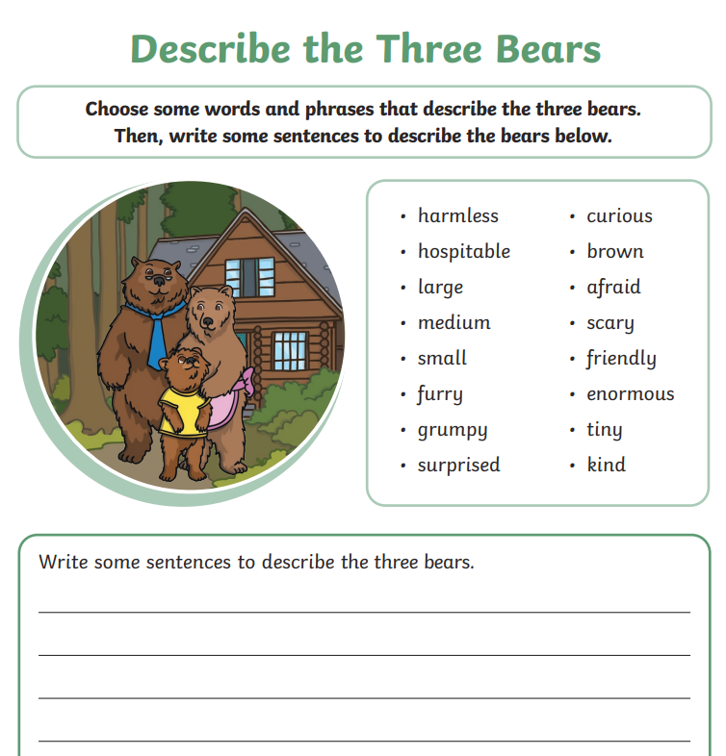  - Remember to use a capital letter at he beginning of your sentences  - Finger spaces  - A full stop at the end of your sentences
Reading | Recommended daily reading time:  KS1 10 minutes
Greek | Please go to Greek Class Blog for Greek Home Learning  Greek Class - St Cyprian's Greek Orthodox Primary Academy

