YEAR 1 HOME LEARNING
Date Set | 05.03424
Date Due | 10.04.24
Maths | Please log onto EdShed (https://www.edshed.com/en-gb/login) where you will find your maths home learning under assignments and spellings Good luck!
Spelling | Writing Task  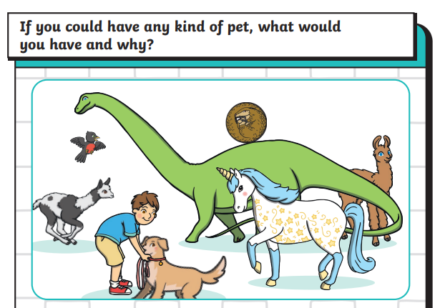  Draw your pet and remember when writing:  - to use a capital letter and full stop.  - finger spaces  - adjectives  - your phonic skills
Reading | Recommended daily reading time:  KS1 10 minutes
Greek | Please go to Greek Class Blog for Greek Home Learning  Greek Class - St Cyprian's Greek Orthodox Primary Academy

