YEAR 1 HOME LEARNING
Date Set | 19.04.24
Date Due | 28.05.24
Maths | Please log onto EdShed (https://www.edshed.com/en-gb/login) where you will find your maths home learning under assignments and spellings Good luck!
Project | Summer Project 1  Create a basket for the lighthouse keeper. Include in your basket food that you know the lighthouse would like to eat. For example: a chicken sandwich, a seafood salad or a healthy oatmeal muffin.  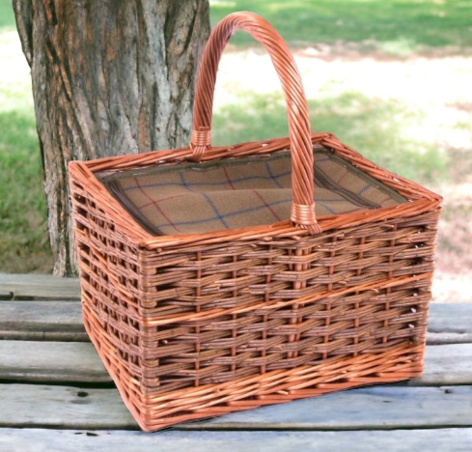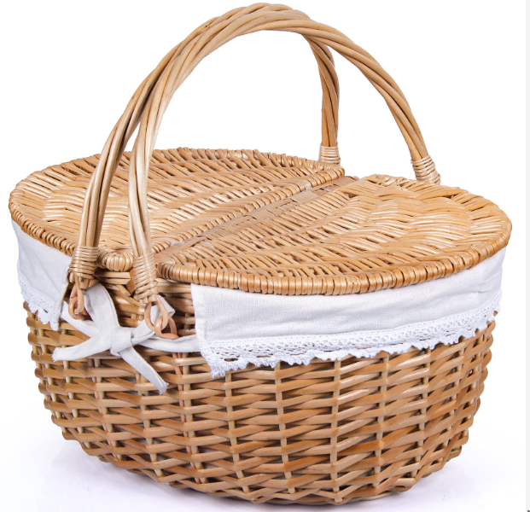  Have fun!
Reading | Recommended daily reading time:  KS1 10 minutes
Greek | Please go to Greek Class Blog for Greek Home Learning  Greek Class - St Cyprian's Greek Orthodox Primary Academy

